MLI Management Module:
- At the time of enrolment of New MLI under CGFMU we are not having an option to upload the below documents as a part of enrolment –
- Scanned copy of undertaking
- Board Resolution Copy
- Any other additional Documents.
Requirement:
New PDF/Word document upload option should be available under below path:
MLI Management > MLI Name >Edit > +Enrol Scheme > Verify Documents (refer below screenprint)
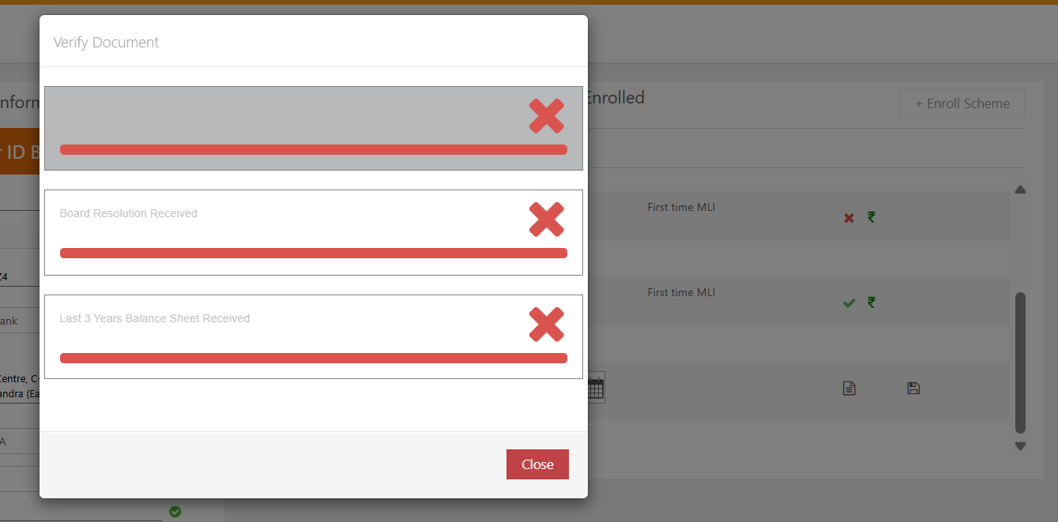

Also, the documents uploaded on this page shall be available to download directly from MLI management on below page as per below:
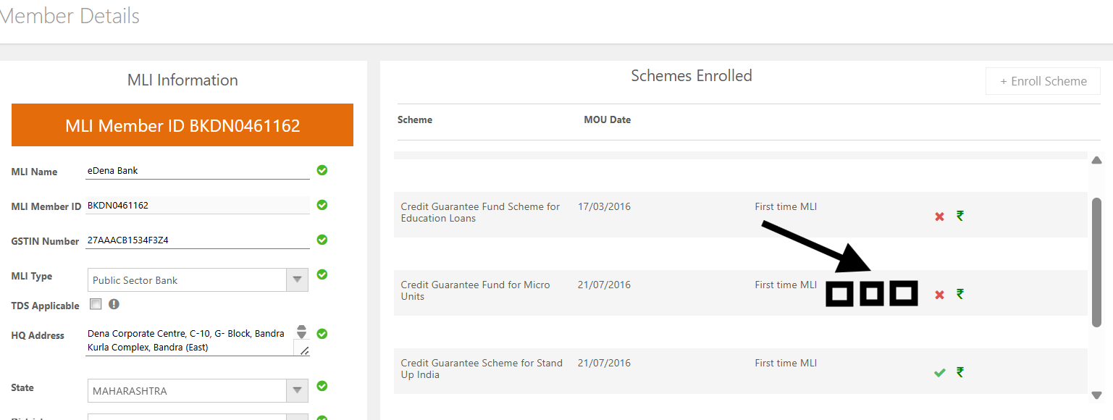
QA for CPR1

- No Effect on other schemes
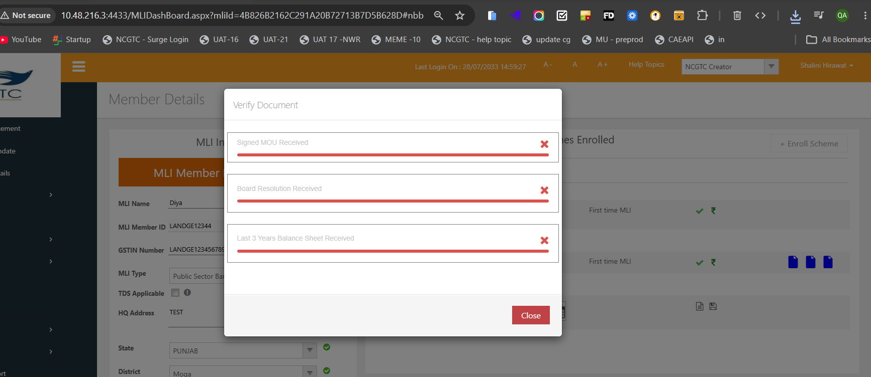

- Under MLI Management Module some fields/columns i.e Administrator, Mobile no. email, Remarks are showing data of Admin users. (Refer below screenshot) 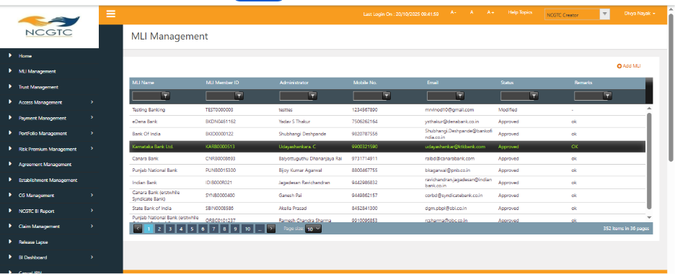
Requirement:
In MLI management dashboard, only MLI member details should be visible i.e. MLI Name, MLI Member ID, GSTIN Number, MLI Type, Email, Website, Status. (refer below screenshot for MLI specific Details)
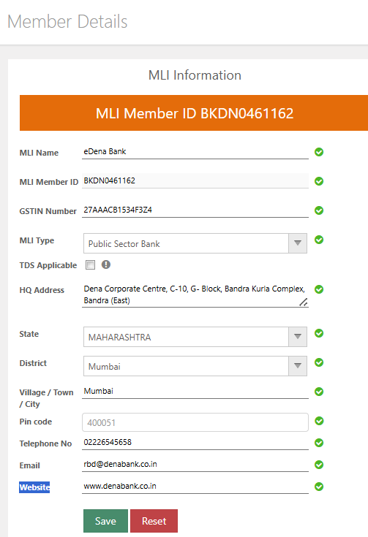

Access Management Module:
- Under MLI Administrator Management: At the time of creation of new Admin users, we are not having an option to upload the SPOC form.
Requirement:
- Need a functionality: upload SPOC (Single Point of Contact) form
- Also need download functionality: NCGTC user should be able to download the uploaded SPOC form against each admin user.
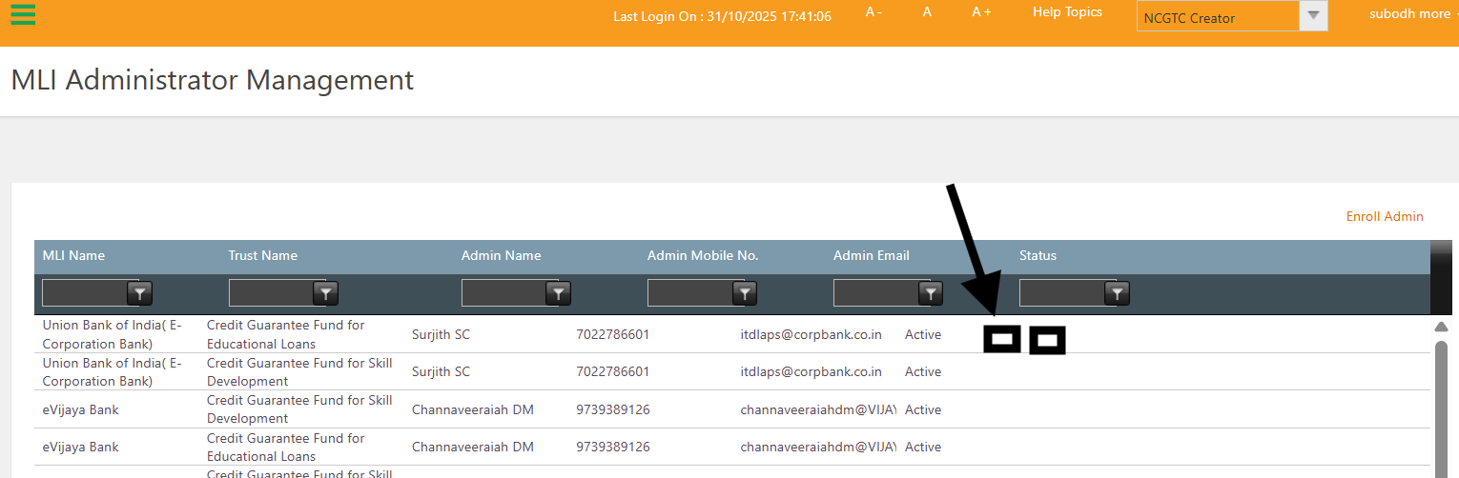

CG Management Module:
- Under Search & view CG: Currently, loan account number/CGPAN is mandatory to find the loan account details.

Requirement:
- Customer ID/Loan account number/CGPAN any one of the three can make it as mandatory to get the loan account details.

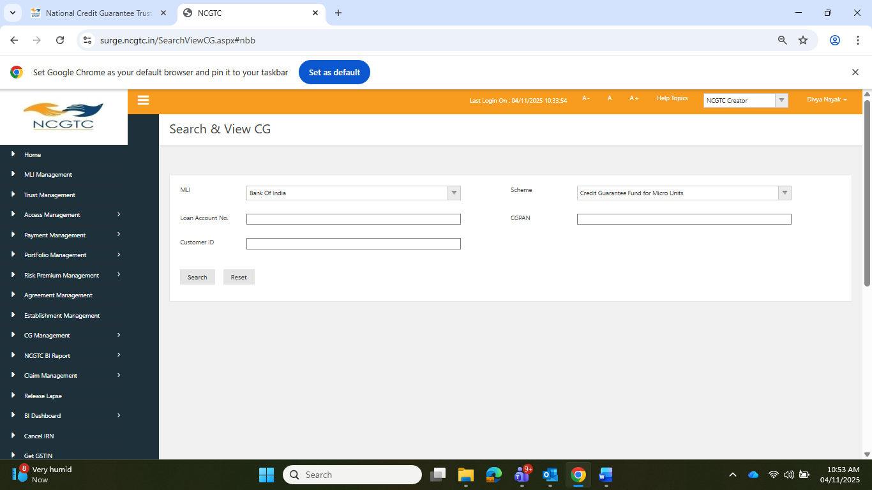

- Additional details required under “Search & view CG”-
MLI Name:
Type of MLI:
CSTIN No.:

New CG/Base Period:
- Portfolio ID
- Customer ID
- Loan Account number
- Category of loan
- Type of loan
- Sanction Date
- Sanction Amount
- Disbursement date
- Disbursement Amount
- CG Cover Amount
- CG fee amount
- Guarantee start date
- Guarantee start date
- Status of loan – Standard/NPA/Close

Update CG
- Category of loan
- Sanction/Modified Sanction Amount
- Sanction /Modified Sanction Date
- NPA – Yes/No
- NPA date
- NPA Outstanding Amount
- Status of loan – Standard/NPA/Close
- Guarantee start date
- Guarantee start date

Claim
- Type of claim – Interim claim 1/Interim claim 2/Final/Migrated Interim claim1/Migrated Claim2/Migrated Final Claim.
- Principal as on date of NPA
- Recovery amount till the lodgment of the claim.
- Portfolio ID
- Total claim settled in the portfolio – claim type wise
- Claim approval date
- Claim payment date and UTR details

Recovery
- Recovered Amount
- Legal Cost
- Recovery Date
The above page shall be visible to both NCGTC and MLI. For MLIs, only respective MLI should be able to view data.

- All the data should be visible to all MLI User ID’s:
Currently, all the data uploaded MLI Maker/Checker IDs is not available to new Maker/Checker IDs (Records and Invoices etc.)

Requirement:
Portfolios wise all the data uploaded by respective MLIs should be visible to all user ID’s irrespective of old/New User IDs of that MLI. Only visibility should be available.
====> page name/ details providec by client to visibe all user ids
payment details, claim mangement details, input file management etc

- Option to upload and download the Statutory auditor’s Certificate, Management Certificate and Bank Mandate under Claim Management Module:

Currently, there is no option to upload statutory auditor's certificate under Claim Management Module after lodging the final claim by MLI.

Requirement:
New PDF document upload option should be available under below path:
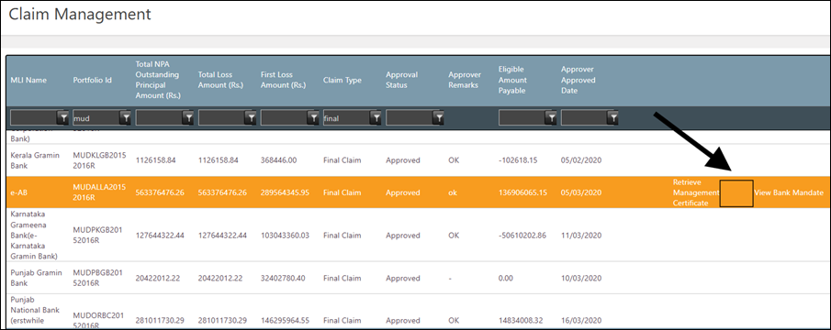
Maker Login> Claim Management > CGFMU Claim Management (refer below screenprint)
Note: The system shall provide an option to upload the Statutory Auditor’s Certificate for all claims. However, uploading the certificate must be mandatory only for the Final Claim.

Print option must be available to save/print the management certificate, Statutory auditors certificate and Bank Mandate from Claim Management Page at MLI and NCGTC users.

- Making provision for guarantee coverage where loan type is 2,3,4 which have remained standard in CP6 period (till March 31)
Currently, no provision available to guarantee coverage for those loan accounts remained standard after Currency Period 6 (Till March 31).
Requirement:
a) Coverage Provision:
- A provision must be made to guarantee coverage for Working Capital accounts that remain standard after Currency Period 6 (CP6).
- This rule is applicable only to Working Capital accounts.
b) Portfolio Upload Requirement
- The MLI must upload these cases in the Base Year file of the following year’s portfolio.
- Such cases should be uploaded as “NEW CG” (New Credit Guarantee).
c) New Field in XML Format
- A new field, “Renewal after CP6”, is to be added in the New CG XML format.
- This field should have Yes/No validation.
d) System Validation:
- If Renewal after CP6 = Yes:
The system must validate the account number to check whether the account was standard in CP6.
- If the account was standard, the system should accept the record.
- If the account was not standard, the system should reject the record.
- If Renewal after CP6 = No:
- the system should perform the existing validation process

CR - 7
1 Verify system accepts renewal only for Working Capital loans (loan type 2/3/4) --> renewal should be done only for working capital ( loan type = 2/3/4)

2 Verify system rejects renewal for Term Loan (loan type 1)

5 Verify Renewal after CP6 = Y & loan account is Standard in CP6 still 30 march (before 31 march of CP6) --->Reject

6 Verify Renewal after CP6 = N & loan account is Standard in CP6 still 30 march (before 31 march of CP6)---> Reject and old validation check

EX
Loan | Old portfolio (CP) | New portfolio (base period)
Loan A | Cp1to6 - Standard | Renewal after CP6 = Y --> Rejct
Loan A | Cp1to6 - Standard | Renewal after CP6 = N --> Rejct old validation check

6 Verify Renewal after CP6 = Y & loan account is Standard in CP6 after 31 march (CP7) ---->Accept

7 Verify Renewal after CP6 = N & loan account is Standard in CP6 after 31 march (CP7) --> Reject and old validation check

Ex
Loan AC | Old portfolio (CP) | New portfolio (base period)
Loan A | CP6 (as on 31 march) - Standard | Renewal after CP6 = Y --> Accept
Loan A | CP6 (as on 31 march) - Standard | Renewal after CP6 = N --> Reject old validation check

8 Verify Renewal after CP6 = Y & loan account is closed --> Reject , as system should not accept duplicate loan account once closed

9 Verify Renewal after CP6 = N & loan account is closed --->Reject , as system should not accept duplicate loan account once closed

10 Verify Renewal after CP6 = Y & loan account A is closed and Loan B is standard for Single cust id
Cust Id | Loan AC  (ex - loan cat - S\K\T) | Old portfolio (CP6- as on 31 march ) | New portfolio
CustA | loanA , Amount = 10K | NPA | -Reject  - Add sanction amount in sum
CustA | LoanB  Amount = 10K | Closed | - Reject  - Don’t add sanction amount in sum
CustA | LoanC  Amount = 10K | Stand | Renewal after CP6 = Y -->Accept  Total sanction amt for CustA = 10K + 10K(NPA) = 20K  Pending limit =10L-20K for CustA

11 Verify Renewal after CP6 = N & loan account A is closed and Loan B is standard for Single cust id ---> Reject , old validation should check

12 Verify Loan account marked as closed in Cp7 (Even after we are not charging CG fee in cp7) ----> as discussed , we need to check status as of 31 march of CP6

Loan AC | Old portfolio (CP) | New portfolio (base period)
Loan A | After CP6 (from 1 April --> Standard | Renewal after CP6 = Y --> Accept
Loan A | After CP6  On 31 march --> Standard  On 2 April --> NPA / close | Renewal after CP6 = Y --> Accept
Loan A |  | Renewal after CP6 = N --> Reject

PortFolio 20-21
As on 31 march - standard - Cp6 --> sanction amount = 10K

Portfolio 30-31
Base period - Renewal -Y , --->
- how sanction amount will work ( increase / decrease / Sum if contain another loan acc in same cust id) ----> As confirmed by divya - don’t allow MLI to change loan category + MLI can add any sanction amount allowcated for that category ( no need to consider previous amount if multiple loan amt not mapped with same cust id
- can I change loan category - NO

- Modification in the MLI information:
Currently, when NCGTC updates any MLI information (e.g., GST Number, Address, Name, Pin code) from MLI management,
All invoices — including previously generated ones — automatically reflect the updated information. This causes retrospective changes to past invoices, which should remain immutable.
Requirement:
When MLI information (GST Number, Address, Name, Pin code, etc.) is modified:
The change should take effect prospectively only.
    - The updated data should apply only to invoices generated on or after the "effective date" (change date).
    - Existing invoices generated before the change date should retain the old information

- Deletion/ Regeneration of Statement of estimate (SOE) and VAN expiry extension:
Currently, there is no option to delete/ regenerate the statement of estimate and extend the VAN Expiry date on the statement of estimate.
However, operational scenarios arise where such actions are necessary to ensure correctness in the system.
Business Scenarios:
- Deletion / Regeneration of Statement of Estimate required in the following cases:
- Account Closure Post SOE Generation. MLI cannot recover CGFEES from the borrower for these accounts.
- Incorrect Information Uploaded by MLI leads to incorrect CGFEES calculation.

- Extension of VAN Expiry Date required in the following cases:
- Technical Issues at MLI/NCGTC End
- Payment could not be completed before the VAN expiry due to system failure or network issues.
- Payment Bounce-Back on Expiry Date
Requirement:
1. NCGTC Maker should get an option to regenerate the generated statement of estimate in Portfolio Management> Portfolio transition > Regeneration Quarter Billing/ year billing option should be available (Refer Below screenshot)
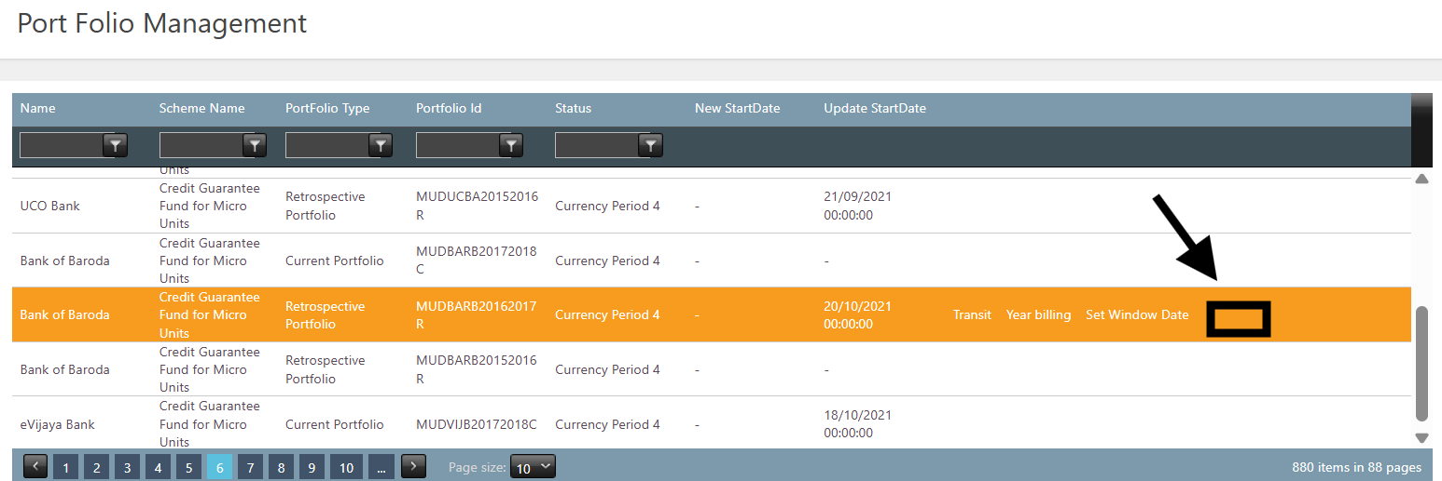
========> on deletion of invoices - what will happen with uploaded new cg in base period
2. NCGTC Maker should get an option to delete generated statement of estimate from Payment Receivable under Payment management > Receipt / receivables. (refer below screenshot)
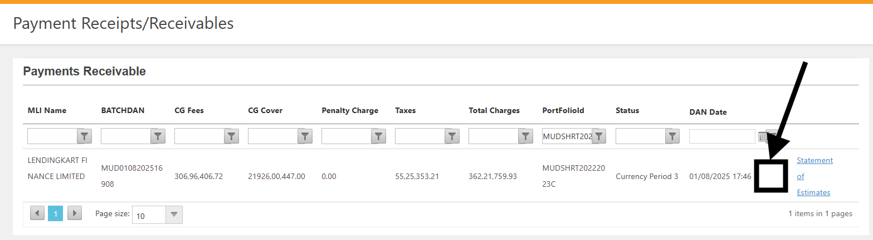
- The VAN Expiry date extension option should be available to NCGT user only (not MLI). Once the statement estimate is generated and visible in Payment Receivable under Payment management > Receipt / receivables. (refer below screenshot)
====> There is payment API on prod - due to this after generating bill by MLI - entry directly goes under Payment Receipt

- Bank mandate view and Scheme name visibility:
- The Bank Mandate upload is currently a one-time activity.
- After the Bank Mandate is received at the NCGTC Maker level for approval, the associated Scheme does not appear on the Bank Mandate approval dashboard.
- This makes it difficult to identify which Bank Mandate corresponds to which Scheme.

Requirement:
- One column needs to be added as Scheme Name at NCGTC Maker and Checker in Bank Mandate >Bank Mandate Approver dashboard (Refer Below screenshot) which helps to identify which Bank Mandate corresponds to which Scheme.

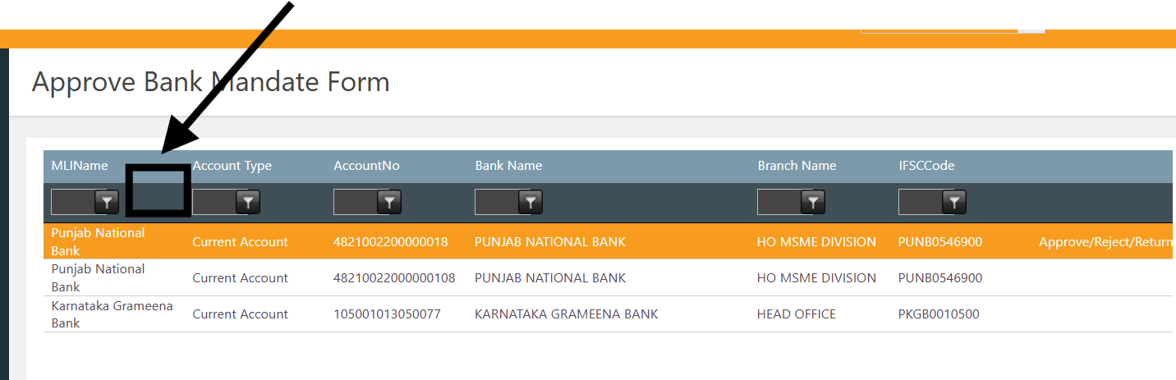

- Summation of sanction amount increases to more than Maximum Limit:

Currently, if the total sanctioned amount of Customer ID exceeds the maximum permissible limit (Mudra – ₹20 lakhs and SHG – ₹20 lakhs), such loan records will be rejected with the message: “Breach of Sanction Limit for Small & Micro Loans. These loan accounts will be revoked.”
This communication is made available to MLI maker through the “Invalid Records” excel file. Despite this notification, if the MLI still approves the update file, the system will automatically closed the Credit Guarantee(s) for the respective customer all the loan records available in the portal, and no billing will be considered for these accounts.

Requirement

  - It should appear in the invalid records only. System should not close those accounts automatically.
  - This validation applicable to both New CG and update CG.

- SHG portfolio Customer ID wise Validation for Sanction Amount

Under the SHG (Self Help Group) portfolio, the system currently performs a validation check to ensure that:
- The account-wise sanction amount is greater than Rs.10lakhs
and Up to Rs.20 lakhs.
- Any record where the sanction amount falls outside this range (less than ₹10 lakhs or greater than ₹20 lakhs) is considered invalid. --> range is More than 10L to 20L (SML)
Requirement
- For the SHG (Self Help Group) portfolio, the validation should be performed Customer ID-wise instead of Account-wise.
- If a single Customer ID is linked to multiple loan accounts,
the sum of all sanction amounts under that Customer ID should not exceed the limit.
- Minimum: Above ₹10 lakhs
- Maximum: Up to ₹20 lakhs
- If the cumulative sanction amount for a Customer ID exceeds Rs. 20 lakhs or falls below ₹10 lakhs, the system should flag those records as invalid.
- This validation rule should be applicable to both New CG and Update CG processes.

1 Data uploaded in same SHG portfolio -->
- New CG / Update CG --> Reject if sum of cust id more than 20L or less than / = 10L
- Sanction amount of closed loan account on same cust id should not be considered in sum

2 Data Already exists other SHG portfolio for same cust id
- New CG / Update CG --> Reject if sum of cust id more than 20L or less than / = 10L
- Sanction amount of closed loan account on same cust id should not be considered in sum

3 Data Already exists other Normal portfolio for same cust id
- New CG / Update CG -->Sanction amount should not be included in SHG portfolios ( sum should be considered only for SHG portfolio) - currently such validations are not exists in system

Sum of Sanction amount check will be done only alogn with SHG portfolios (if same cust if exists in normal portfolio , that amount will not consider under sum for SHG portfolio)
EX
Normal portfolio , for cust ID A,sanction amount is 10L
Then
for SHG-20-21 for cust ID A , sanction amount is 5L
for SHG-22-22 for cust ID A , sanction amount is 6L

Then sum will be 6L (not consider sanction amount of normal portfolio)

- Updating the Status of the Portfolio:
As per the CGFMU Scheme Guidelines, the “Currency of the Portfolio” is defined as: Three complete financial years from the end of the date of crystallization of the portfolio. Accordingly, the total period of currency for any portfolio will be:
Base Year + Three Complete Financial Years
The portfolio remains active even after the entire defined currency period as per the scheme rules. Hence, irrespective of the status of the portfolio which may be LIVE or Closed, all the portfolios are shown as LIVE portfolios in the MIS Reports which is misleading.
Requirements:
NCGTC Maker and Approver:
- One column should be added in the Portfolio Management module under “Portfolio transition” as “Current Portfolio Status”.
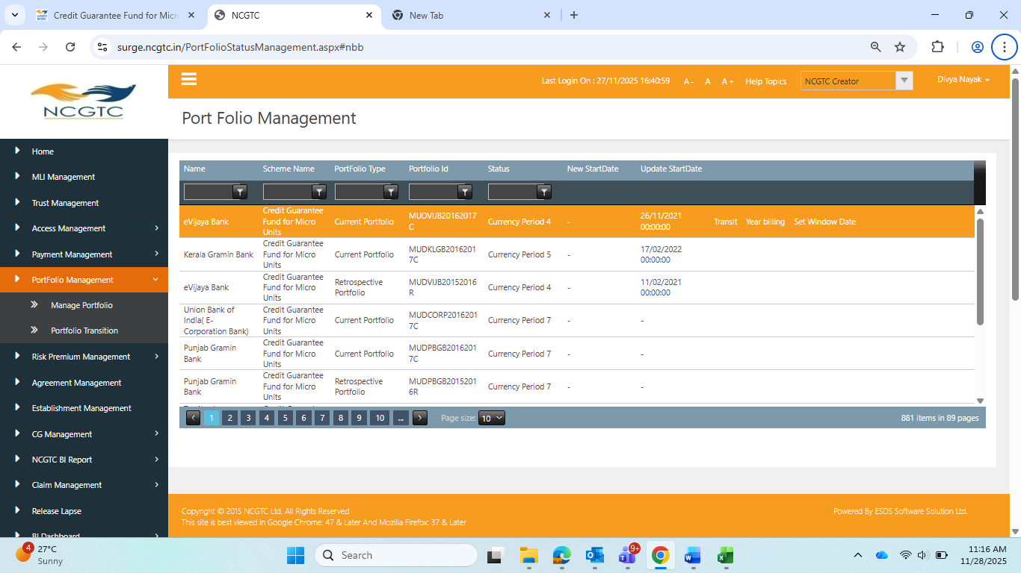

Under status of the portfolio –
- If any portfolio is not Migrated, then portfolio status should be “Closed”.
Logic:
    - If CP4 billing process (Including payment) is not completed, then portfolio status should be “Closed”. Effective date: 1st April of the CP5 period.
    - From CP1 to CP3 any of the currency period CG fee payment is not completed, then immediate next period portfolio status mark as “Closed”. Effective date: 1st April of the immediate next CP period. ie, if CP1 billing is not done, portfolio status marked as closed effective date should be 1st April of the CP2 period.
- If any portfolio is Migrated, then portfolio status should be “Migrated Live”.
Logic:
    - CP4 billing process (including payment) completed then portfolio status should be “Migrated Live”. Effective date: 1st April of the CP5 period.

- If any Migrated live portfolio closed, the portfolio status should be “Migrated Closed”.
Logic:
    - If CP6 billing process (Including payment) is completed, then portfolio status should be “Migrated Closed”. Effective date: End of the CP7period.
    - From CP5 to CP6 any of the currency period CG fee payment is not completed, then immediate next period portfolio status mark as “Migrated Closed”. Effective date: 1st April of the immediate next CP period. ie, if CP5 billing not done, portfolio status marked as Migrated closed effective date should be 1st April of the CP6period.
- If any portfolio is Live, then portfolio status should be “Live”.
Logic: –
    - From CP1 to CP3 all of the currency period CG fee payment is completed, then immediate next period portfolio status mark as “Live”. Effective date: 1st April of the immediate next CP period.
ie, if CP1 billing process completed, portfolio status marked as “Live” effective date should be 1st April of the CP2 period.
- MIS reports -
a) Monthly basis Performance summary report required as per the below –
  - Migrated portfolios – Data already available monthly basis
  - Closed portfolio data
  - Live portfolios data (including migrated live portfolios).
Portfolio Financial Year | No. of Loan Records | Sanctioned Amount | Live Loan Count | Live Outstanding Amount | CG Fees | NPA Loan Count | NPA Outstanding Amount | Claims Settled Amount | NPA%

b) MLI wise performance report required as per below –
  - Migrated portfolios – Data already available monthly basis
  - Closed portfolio data
  - Live portfolios data (including migrated live portfolios).
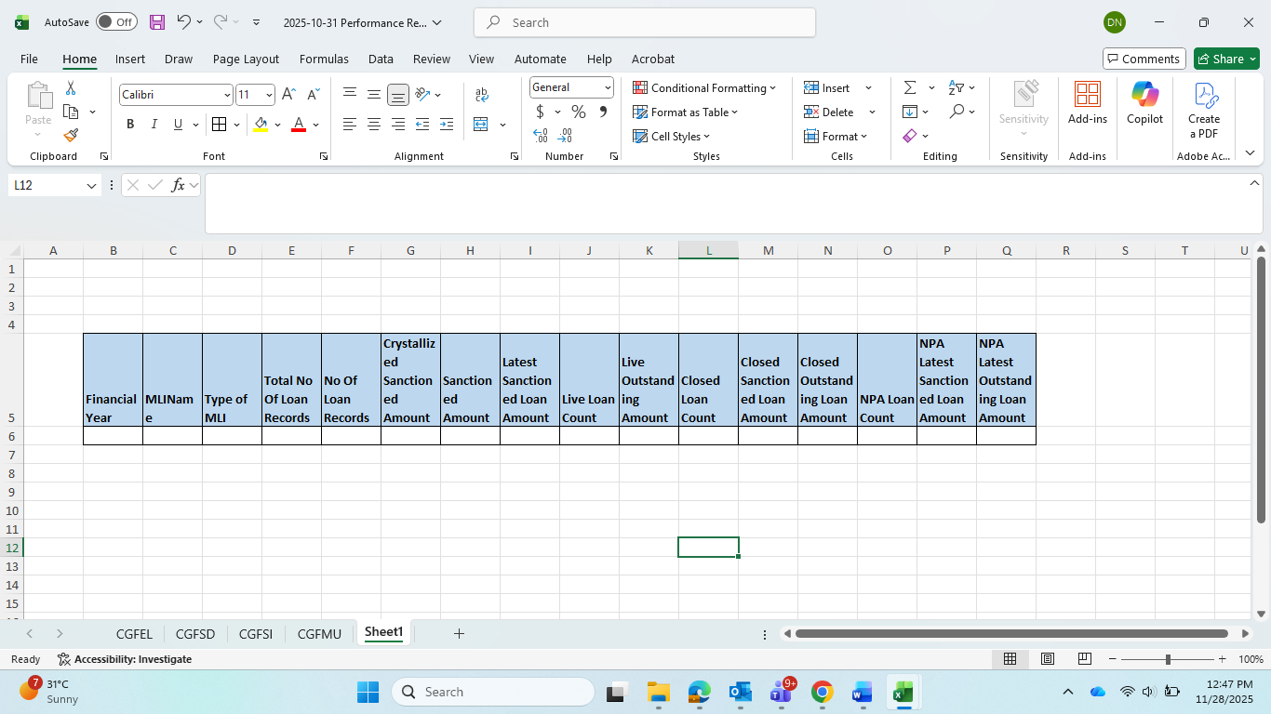
- MLI wise portfolio status report - This report is available both NCGTC and MLI side.
- For NCGTC all MLI portfolios report available.
- For MLI – respective MLI portfolio wise report available.
MLI Name | Type of MLI | Portfolio ID | Portfolio Type | status | Current portfolio status

MLI Creator Login under “Input file Management”-
- One column should be added in the “Input file Management” next to the portfolio selection as “Status of the Portfolio”
- Under Portfolio selection whichever portfolio is selected by MLI, status of that portfolio should be reflected. Ie, Closed, Live, Migrated Live, Migrated closed.
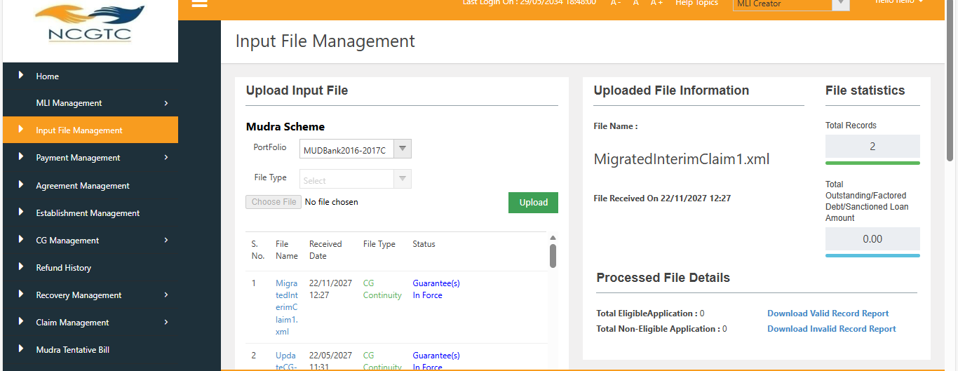

- Additional validations in the claim lodgment process under CGFMU
Currently, the Principal as on the date of NPA and the recovery amount up to the lodgment of the claim must be uploaded by the MLI while lodging the claim in the Surge portal. Since CGFMU claims are portfolio-based combined claims, the accounts for which claims have already been lodged should be included in the subsequent claims as well.

At present, there is no validation to ensure that the updated principal amount and the recovery amount (as on the date of claim lodgment) match or correspond with the amounts reported in the subsequent account-wise lodged claims.

Requirements (In addition to the existing validation):

a) Portfolio wise validation should be implemented while uploading the claim xml file -
  - The account-wise principal amount as on the date of NPA should remain unchanged, unless the account becomes Standard and subsequently turns NPA again.
  - The cumulative recovery amount should be updated in each subsequent claim.
Eg:
Interim Claim 1/ Migrated Portfolio Interim Claim 1:
Customer ID | Loan account No. | Principal as on date of NPA | Recovery till the lodgment of the claim
A | 1 | 15000 | 1400
B | 2 | 171123 | 12800
C | 3 | 20453 | 8760
D | 4 | 210672 | 90000

Interim Claim 2/ Migrated Portfolio Interim Claim 2:
Customer ID | Loan account No. | Principal as on date of NPA | Recovery till the lodgment of the claim | Validation
A | 1 | 15000 | 1400 | a) Those accounts included in the interim claim 2, Principal amount as on date of NPA should be same as Interim Claim 1, unless the account becomes Standard.  If principal amount as on date of NPA not matching as per updated interim claim 1, system should throw an error and same shall be appeared in the invalid records.  b) Recovery amount till the lodgement of the claim should not be less than the amount entered in the interim claim1.  If recovery amount is less than updated amount in interim claim 1, system should throw an error and it should appear in the invalid records.  c)MLI should get an option to correct and re-upload the invalid records before processing the file.
B | 2 | 171123 | 14900
C | 3 | 20453 | 10760
D | 4 | 210672 | 101000
E | 5 | 80250 | 15000 | New NPA accounts added in Claim 2.
F | 6 | 23458 | 7100 | New NPA accounts added in Claim 2.

Final Claim/Migrated Portfolio Final Claim
Customer ID | Loan account No. | Principal as on date of NPA | Recovery till the lodgment of the claim | Validation
A | 1 | 15000 | 1500 | a) Those accounts included in the final claim, Principal amount as on date of NPA should be same as Interim Claim 2, unless the account becomes Standard.  If principal amount as on date of NPA not matching as per updated interim claim 2, system should throw an error and same shall be appeared in the invalid records.  b) Recovery amount till the lodgement of the claim should not be less than the amount entered in the interim claim2. If recovery amount is less than updated amount in interim claim 2, system should throw an error.  c)MLI should get an option to correct and re-upload the invalid records before processing the file.
B | 2 | 171123 | 14900
C | 3 | 20453 | 11760
D | 4 | 210672 | 151000
E | 5 | 80250 | 25000
F | 6 | 23458 | 8100
G | 7 | 145600 | 10500 | New NPA accounts added in Final claim.

b) Currently, the Management Certificate does not display the Type of claim ie, Interim claim1, Interim Claim2, Final claim, MP interim claim 1, MP interim claim2 and MP Final claim. The same should be visible in each claim.
c) On the Home page, while downloading the ‘Valid Records’ from the claim file, NPA date should be included in valid records.
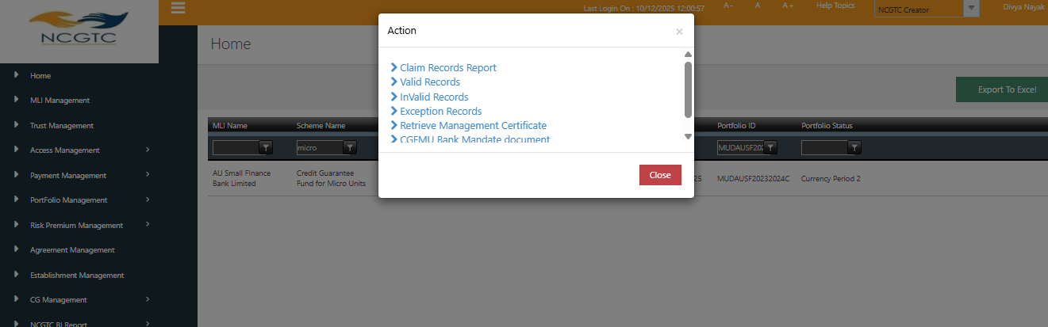

- Crystalized Sanction Amount
As per the CGFMU guidelines “crystallization of the portfolio” is the end of the financial year (March 31) in which the portfolio is built up (base year). Under CGFMU the total claim payout ratio would be capped at 15% of the original sanctioned guaranteed limit.

At present, the crystallized sanction amount is recalculated at every claim lodgement (such as Interim Claim 1, Interim Claim 2, Final Claim, etc.). The revised crystallized value represents the total of the modified sanction amounts across the portfolio.

Requirements
The total claim payout ratio shall be restricted to 15% of the original sanctioned guaranteed limit. Consequently, the crystallized sanction amount applicable to all lodged portfolios will be identical to the original sanctioned guaranteed limit.
For every Management Certificate generated within the portfolio, the crystallized sanction amount must be fixed equal to the original crystallized portfolio amount, and it should not change.

- Guarantee coverage for modified sanction amount
Current system - Guarantee Fee on Modified Sanction Amount
As per the CGFMU scheme guidelines –
“For the Base year,” - Guarantee fee will be paid on the sanctioned amount corresponding to the outstanding balance of the quarterly built up balance of the portfolio of micro loans for the full year or the broken period i.e. till March 31 of the subsequent year, as the case may be, and the Guarantee will be valid upto the end of that financial year and guarantee fee shall be paid within 16 days from the end of the quarter.
“For subsequent years”, data of live portfolio of accounts (including NPA accounts) of previous years for which guarantee is sought to be continued during the Financial Year will be furnished by the MLI on or before July 31 and Annual Guarantee fee shall be paid on or before August 31 or such other date as may be decided by NCGTC to enable guarantee cover for the Financial Year.”
Currently, when the MLI updates the modified sanction amount for an account after the guarantee fee has already been paid, using the Update File, the system does not calculate the guarantee fee on the additional/enhanced sanction amount.
As a result, the enhanced portion of the loan remains without guarantee coverage, creating a gap in guarantee protection for modified accounts.
Requirements
Modified Sanction Amount After CG Fee Payment:
If the MLI updates the sanction amount for any account after the CG (Credit Guarantee) fee has already been paid, the system should follow these steps:
  - Guarantee Fee for the Enhanced Portion
- The CG fee for the additional or enhanced portion of the sanction amount shall be calculated on a pro-rata basis (for broken period) from the date of modification to the end of the financial year, whenever the MLI updates the modified sanction amount.
- Once the file is completely processed, the system should auto generate the statement of estimate invoice based on the enhanced portion.
- After generation of the Statement of estimate invoice the same shall be notified to MLI by email as well as in portal for making the payment.
- All other payment and reconciliation method remains same.

- Additional fields needs to be added in the New CG File format under CGFMU
Below are the 3 additional fields included in the New CG format:
    - Whether collateral security obtained?
    - Whether third party guarantee obtained obtained?
    - Business loans outstanding at the time of sanction as per Credit Bureau report (We have already provided the Change request on this dated 30/09/2025).
Validations required for point no. (a) and (b) –
- If the MLI update Collateral security and Third-party guarantee obtained field is “Yes” then system should reject the record.
- If the MLI update Collateral security and Third-party guarantee obtained field is “No” system should accept the record for further process.

